Estimating Carrying Capacity for Chinook Parr using Quantile Random Forest Models

Kevin E. See1,✉, Michael W. Ackerman1, Richard A. Carmichael1, Sarah L. Hoffmann1, and Chris Beasley1

June 11, 2020

Needs more…

The QRF model presented here provided estimates of habitat carrying capacity for Chinook salmon parr during the summer months, at both the site and watershed scale. Total capacity estimates for watersheds closely matched estimates from alternative fish productivity models. Carrying capacity estimates based on QRF, like those presented here, provide managers a framework to guide the identification, prioritization, and development of habitat rehabilitation actions to recover salmon populations.

1 Biomark, Inc. 705 South 8th St., Boise, Idaho, 83702, USA

✉ Correspondence: [Kevin E. See <[Kevin.See@merck.com](mailto:Kevin.See@merck.com)>](mailto:Kevin.See@merck.com)

# Introduction

The decline of anadromous Pacific salmonids (*Oncorhynchus spp.*) across the Pacific Northwest, USA has prompted numerous actions aimed at reversing that trend. These actions are often categorized into four H’s – harvest modification, hatchery practices, hydro-system operations, and habitat rehabilitation. Problematically, there is substantial uncertainty regarding the degree of change that can be exerted across and within these categories, and what combination of changes will most cost-effectively and sustainably reduce mortality. Recently released “de-listing” criteria (NOAA Fisheries 2016a, 2016b) identified adult escapement targets at the population scale, providing a quantitative metric useful for evaluating the magnitude of survival improvements required. These abundance targets provide a benchmark against which habitat rehabilitation actions can be measured. Here we describe an approach for estimating life-stage specific habitat-based carrying capacity that can be used to quantitatively identify the magnitude of tributary habitat rehabilitation necessary to support de-listing. For perhaps the first time, the necessity of tributary habitat restoration can be demonstrated and the magnitude of required change can be placed in context with the other “H’s.”

Pacific salmon (*Oncorhynchus spp.*) species have experienced large declines in abundance throughout much of their range (Good et al. 2005). Declines can be partially attributed to lost or altered habitat, and thus, efforts to recover depleted salmon populations are replete with efforts to rehabilitate habitat used during the freshwater life-stages. Specifically, restoring salmonid carrying capacity through tributary rehabilitation actions has been identified as a key component of recovery efforts for salmon and steelhead (*Oncorhynchus mykiss*) in the Pacific Northwest, USA (NOAA Fisheries 2016a, 2016b). Efforts have included increasing and improving existing habitat for both spawning adults and rearing juveniles. However, estimating habitat carrying capacity, both historic and contemporary, for various life-stages of Pacific salmon, as well as identifying important habitat characteristics that influence capacity, has been an ongoing but necessary challenge. Reliable methods to better understand fish-habitat relationships as well as to estimate capacity are necessary to identify those salmon and steelhead life-stages that are limited by habitat capacity, and further, to better direct tributary rehabilitation efforts.

Fausch et al. (1988) conducted a thorough review of attempts to predict the standing crop of fish from measurable habitat covariates from 1950 to 1985, and found that the vast majority of multiple linear regression models failed to detect a significant fish-habitat signal. Since that review, there has been progress in identifying some fish-habitat relationships for some salmonid species. Nickelson et al. (1992) found that juvenile coho were found in higher densities within pool habitat on the Oregon coast. Similarly, pool and pond densities were good predictors of coho smolt densities in western Washington (Sharma and Hilborn 2001). Bryant and Woodsmith (2009) found that juvenile coho abundance was positively related to large wood at the reach scale, however their results demonstrated a negative relationship between abundance and the number of pools. Braun and Reynolds (2011) similarly found positive associations between spawner densities of sockeye in the Fraser River and large wood, in addition to positive relationships to percent undercuts and percent pools. Densities of adult spawning coho were also higher in forested areas compared to urban or agricultural areas in the Snohomish River watershed (Pess et al. 2002). Mossop and Bradford (2006) examined juvenile Chinook in the Yukon river and found positive correlations between the log of fish density and several metrics related to residual pool dimensions and large woody debris abundance as well as a negative correlation between fish density and gradient. These studies were focused on predicting observed fish densities, not necessarily capacity, and for most of them the predictive extent is limited to a particular watershed. In addition, they all assumed some form of linear fish-habitat relationship, which often results in weak predictive power.

A number of studies have utilized other modeling approaches to elicit non-salmonid fish habitat relationships. Dunham et al. (2002) used a quantile regression approach to show a negative relationship between cutthroat trout densities and the width:depth ratio of a stream for the upper quantiles of trout density. The same approach was also used to map the potential extent of sole in the English Channel and southern North Sea (Eastwood et al. 2003). Machine learning models such as boosted regression trees and random forests have been used to examine species biomass, diversity and distribution for a number of different species (Pittman et al. 2009, Knudby et al. 2010, and Compton et al. 2012). Wall et al. (2016) took a bioenergic approach to predict the capacity of a reach to support juvenile steelhead. The results from these studies highlight the importance and effectiveness of using techniques that can accommodate non-linear fish habitat relationships.

Most studies that have investigated fish-habitat relationships focus on predicting a species’ distribution (presence / absence) or the average abundance or density, neither of which can be easily manipulated to predict carrying capacity. Further, many of these studies focus on only one or two measures of habitat. Sweka and Mackey (2010) estimated carrying capacity of Atlantic salmon parr using a quantile regression approach, but the only habitat covariate they included was cumulative drainage area. Traditionally, carrying capacity for salmonids has been estimated through stock-recruitment curves. However, this requires a long time-series of data with variety in the number of spawners which is not usually available (Cramer and Ackerman 2009).

In fisheries it has long been recognized that both biotic and abiotic factors limit productivity within and across life-stages. For the purposes of this paper, we define carrying capacity as the maximum number of individuals that can be supported given the quantity and quality of habitat available at a given life-stage. We assume that higher observed relative densities within a given life stage are a function of habitat quantity and quality. Furthermore, we assert that observed fish density is a poor predictor of habitat capacity owing to both a paucity of individuals, especially for threatened or endangered species, and the existence of unmeasured variables that may serve to limit capacity. To address this, we have developed a model to estimate juvenile rearing capacity for Pacific salmon in wadeable streams based on quantile random forest (QRF) (Meinshausen 2006) models using measurements of fish abundance (and density) and habitat characteristics. QRF models combine the theory and justification of quantile regression modeling (Koenker and Bassett Jr 1978, Cade and Noon 2003) with the flexibility and framework of random forest models (Breiman 2001). They account for unmeasured variables and can be used to describe the entire distribution of predicted fish densities for a given set of habitat conditions, not just the mean expected density. Random forest models have been shown to outperform more standard parametric models in predicting fish-habitat relationships in other contexts (Knudby et al. 2010). Quantile regression forests share many of the benefits of random forest models, such as the ability to capture non-linear relationships between independent and dependent variables, naturally incorporate interactions between covariates, and work with untransformed data while being robust to outliers (Prasad et al. 2006). Meanwhile, quantile regression models have been used in a variety of ecological systems to estimate the effect of limiting factors (Terrell et al. 1996, Cade and Noon 2003).

The fish abundance/density and habitat data used to fit the QRF model presented here were available from seven watersheds within the interior Columbia River basin, Pacific Northwest, USA. Within the interior Columbia River basin two major runs of Chinook salmon (*Oncorhynchus tshawytscha*) occur, stream-type (i.e., spring/summer run) and ocean-type (i.e., fall run), each characterized by different life history characteristics. Stream-type Chinook salmon enter freshwater earlier in the year, spawn in the upper reaches of a watershed, and the juveniles rear for up to 16 months in the freshwater before entering the ocean as smolts. Ocean-type Chinook salmon enter freshwater later (e.g. fall or winter) spawn lower in the watershed, and the juveniles may only spend between several weeks and six months in freshwater before migrating to the ocean. Here we focus on juvenile stream-type Chinook, in particular the summer rearing period during low flow. Data presented here are from Chinook salmon populations in the Upper Columbia River spring-run and Snake River spring/summer-run Evolutionary Significant Units (ESU). The Upper Columbia spring-run ESU is listed as endangered under the Endangered Species Act, the Snake River spring/summer-run is listed as threatened (NOAA Fisheries 2016a, 2016b). Hereafter, we refer to both ESUs simply as Chinook salmon.

In this study, we developed a QRF model to

1. Identify measured habitat characteristics that are most strongly associated with observed Chinook salmon parr abundance and density,
2. Use paired fish and habitat measurements to elicit fish-habitat relationships for those habitat characteristics identified as important for determining fish abundance and density,
3. Predict contemporary habitat carrying capacity at all sites where the important habitat characteristics are measured (i.e., CHaMP sites within the Columbia River basin),
4. Extrapolate capacity predictions at CHaMP sites across a watershed using globally available attribute data to estimate the Chinook salmon parr capacity of that watershed, and
5. Validate estimates of carrying capacity from our approach across multiple watersheds using independent estimates of capacity (e.g., spawner-recruit relationships).

This manuscript incorporates multiple measures of stream habitat to estimate fish-habitat relationships that encompass the collinear nature of most stream habitat metrics and can be used to predict carrying capacity. Our approach moves across several spatial scales, inferring fish-habitat relationships from detailed, localized habitat data and extrapolating capacity predictions across wide swaths of unsampled locations.

# Methods

## Study Site

Habitat data used in our study were collected from eleven watersheds within the interior Columbia River basin, Pacific Northwest, USA (Figure 1). The Columbia River basin covers more than 668,000 km $​^{2}$ draining large portions of Idaho, Oregon, and Washington, and smaller portions of Montana, Nevada, Utah, and Wyoming, as well as the southeastern portion of British Columbia. The habitat data used to populate the QRF model were collected by the Columbia Habitat Monitoring Program (CHaMP) (Volk et al. 2017) and were downloaded from <https://www.champmonitoring.org>. Data from the following eleven CHaMP watersheds were used in this study: Asotin, Entiat, John Day, Lemhi, Methow, Minam, South Fork Salmon, Tucannon, Upper Grande Ronde, Wenatchee and Yankee Fork. Juvenile density and abundance data were collected in a subset of seven watersheds (see Table 1 and Figure 1), at CHaMP survey reaches and were graciously provided by a number of projects, including the Integrated Status and Effectiveness Monitoring Project (Volk et al. 2017).

## Data

CHaMP sites are 200 m to 500 m reaches within wadeable streams across select basins within the interior Columbia River basin selected based on a spatially balanced Generalized Random Tesselation Stratified sample selection algorithm (Stevens Jr and Olsen 1999, 2004). Habitat data within CHaMP sites were collected using the CHaMP protocol (CHaMP 2016) which calls for field data collection during the low-flow period, typically from June through October. CHaMP habitat data include, but are not limited to, measurements describing channel complexity, channel units, disturbance, fish cover, large woody debris, riparian cover, stream size (depth, width, discharge), substrate, temperature, and water quality.

Juvenile fish surveys were conducted for Chinook salmon parr during the summer low-flow season at many of the same sites surveyed using the CHaMP protocol. Survey methods included mark-recapture, three-pass removal sampling, two-pass removal sampling, and single-pass electrofishing, as well as snorkeling. These data were used to estimate Chinook salmon parr abundance at all CHaMP sites where fish survey data were available. Three-pass removal estimates used the Carle-Strub estimator (Carle and Strub 1978), following advice from Hedger et al. (2013). Two-pass removal estimates used the estimator described by Seber (2002). Mark-recapture estimates used Chapman’s modified Lincoln-Peterson estimator (Chapman 1951) and were deemed valid if they met the criteria described in Robson and Regier (1964). These estimates were made using the *removal* function from the *FSA* package (Ogle et al. 2019) or the *closedp.bc* function from the *Rcapture* package (Rivest and Baillargeon 2019) in R software (R Core Team 2019). Snorkel counts were transformed to abundance estimates using paired snorkel-electrofishing sites to calibrate snorkel counts. For sites with invalid estimates or that were sampled with a single electrofishing pass, we developed an estimate of capture probability based on valid estimates, using a binomial generalized linear mixed effects model. Fixed effects were species, wetted width of the site, density of fish caught on the first pass and all possible two-way interactions. We included a random effect for fish crew / watershed. We used this model to predict abundances based on the number of fish caught on the first pass and any other covariates.

Abundance estimates at all sites were then translated into linear (parr/m) fish densities which were paired with the associated CHaMP habitat data. For sites that were sampled in multiple years, only the fish and habitat data from the year with the highest observed fish density was retained to avoid possible pseudo-replication, while remaining consistent with our goal of estimating carrying capacity. After removing duplicate samples, our initial dataset contained 327 unique sites with paired fish-habitat data (Table 1).

## Habitat Covariate Selection

A key step in developing a QRF model to predict fish capacities was selecting the habitat covariates to include in the model. The CHaMP program generated more than 100 habitat metrics at each site, many of which were correlated with each other to one degree or another, as is often the case with stream habitat variables. We sought to include a small set of covariates that were not overly redundant (i.e. not highly correlated), described many aspects of stream habitat (e.g. substrate, temperature, complexity, etc.) and were highly associated with the observed fish densities, presumably because they contained information about what types of habitat fish sought or avoided. Full details of how covariates used in the QRF model were selected can be found in Appendix S1.

## QRF Model Fit

Using the selected habitat covariates (Table 2), we fit a QRF model to predict habitat rearing capacity for Chinook salmon parr, during summer months, using the natural log of fish densities as the response. After constructing a random forest, predictions of the mean response can be made by averaging the predictions of all trees, similar to the expected value predictions from a statistical regression model. However, the individual predictions from each tree, viewed collectively, describe the entire distribution of the predicted response, therefore, the random forest model can be used in the same way as other quantile regression methods to predict any quantile of the response. There were missing values for some habitat data; thus, any site visit with more than three missing covariates was removed from the dataset and the remaining missing habitat values were imputed using the *missForest* R package (Stekhoven and Bühlmann 2012, Stekhoven 2013). We fit the QRF models using the *quantregForest* function from the *quantregForest* package (Meinshausen 2017) in R software (R Core Team 2019), incorporating data from 327 records (paired fish-habitat data) and twelve habitat covariates (27.2 data points per covariate) (Table 2). The 90th quantile of the predicted distribution was used as a proxy for carrying capacity, following the suggestion of Sweka and Mackey (2010), and to avoid higher quantiles that draw from the very upper tails of observed fish density, where the variability of predictions may be influenced by small sample size issues.

After model fitting, the QRF model was then used to predict capacity at sites with measurements of the habitat covariates that were used to fit the model. In our case, this includes all sites within CHaMP basins in the interior Columbia River basin. For CHaMP sites that were sampled in multiple years, we first calculated the mean for each habitat metric among years to make predictions. In total, we generated 589 predictions of Chinook salmon parr capacity, during summer months, for the following basins: Entiat, Grande Ronde (including Minam), John Day, Lemhi, Methow, South Fork Salmon, Tucannon, Wenatchee and Yankee Fork.

## Extrapolating to Other Sites

To predict capacity at larger spatial scales, such as the watershed or population, we developed two extrapolation models (linear and areal capacity) based on globally available attributes (GAA) which were available for the entirety of tributary habitat utilized by a given population. The GAA data used here was taken from the list of Generalized Random Tesselation Stratified master sample sites that the CHaMP sites were originally selected from (Larsen et al. 2008, 2016). Possible covariates included temperature range, growing degree days, an index of disturbance, the square root of cumulative drainage area, stream power, slope, channel type and watershed (Table 3). The natural log of the CHaMP site capacity predictions was used as the response variable in a multiple linear regression model that incorporated the design weights of the CHaMP sites using the *svyglm* function from the *survey* package (Lumley 2019) in R software (R Core Team 2019). We fit two extrapolation models to each type of fish density, one that included watershed as covariate, for use in predicting capacity within CHaMP watersheds, and one that did not, for predicting everywhere else. We then made predictions of linear and areal capacity at all master sample sites throughout the interior Columbia River basin, generally spaced about one kilometer apart. Summaries of extrapolation model fit are shown in Table 4.

To summarize capacity at larger scales, the mean linear capacity (e.g., fish/m) of the master sample points along a particular tributary is multiplied by the length of that tributary. We first restricted the master sample points and lengths of streams to those with the domain of spring/summer Chinook salmon, as defined by StreamNet (<http://www.streamnet.org> ) or using expert opinion from local biologists. The capacities of various tributaries could then be summed to estimate capacity at almost any spatial scale.

## Model Validation

Spawner-recruit data from several watersheds within the interior Columbia River basin were compiled to validate the extrapolated QRF estimates of spring/summer Chinook salmon parr capacity. Some watersheds had direct estimates of parr, while some had estimates of smolts and pre-smolts (i.e. fall emigrants) from rotary screw traps. For the latter, estimates of parr were calculated using estimates of over-winter survival. A series of spawner-recruit functions were then fit to this data including Beverton-Holt, Ricker, and hockey stick, using the *FSA* package (Ogle et al. 2019) in R. Estimates of capacity from each of these spawner-recruit curves were compared with QRF estimates of capacity for the same regions.

# Results

## Habitat Covariate Selection

We categorized 165 habitat measurements collected using the CHaMP habitat protocol (CHaMP 2016) into eleven habitat categories, and for each habitat covariate an MIC value was calculated based on the strength of association between the habitat covariate and the response variable, parr density (fish/m). We chose the following twelve CHaMP habitat covariates to fit the QRF model: wetted width, observed discharge, average August temperature, wetted width:depth ratio, percent fines less than 6 mm, total percent fish cover, channel unit frequency, standard deviation of the wetted depth, frequency of large wood in pools, percent riparian canopy cover, lower quantile of substrate size (D16) and braidedness (Table 2).

## QRF Model

A QRF model was fit using those metrics and the *quantregForest* package (Meinshausen 2006) in R (R Core Team 2019) and the 90th quantile of the predicted distribution was used as a proxy for carrying capacity. After model fit, we examined the relative importance of each habitat covariate included in the model (Figure 2). Moreover, QRF models allow one to visually examine the marginal effect of each habitat covariate on the quantile of interest using partial dependence plots. These plots show the marginal effect of changing a single habitat covariate while maintaining all other covariates at their mean values (Figure 3). However, given that many habitat metrics are somewhat correlated, these marginal effects are often not independent of one another, so care should be taken when interpretting them. After model fitting, the QRF model was used to predict habitat capacity at all CHaMP sites within the interior Columbia River basin.

## Extrapolating to Other Sites

We fit a linear regression extrapolation using QRF-based predictions of capacity at all CHaMP sites as the response, and various GAAs as the independent variables. The coefficients for the extrapolation model can be found in Table 3. From this, we have estimates of capacity at every master sample point in the Columbia River basin, which are located approximately one kilometer apart.

## Model Validation

Estimates of Chinook salmon parr capacity from the QRF and extrapolation models were comparable to independent estimates from spawner-recruit data (Table 5, Figure 4). QRF estimates had overlapping confidence intervals with one or more of the Beverton-Holt, Ricker, or hockey stick model estimates in each of the nine locations where comparisons were possible (Figure 4). Possible additional uncertainty was not accounted for in estimates of spawners-per-redd or spawners-per-parr, which would increase the confidence intervals around spawner-recruit estimates and the overlap among estimates. Correlations between parr capacity estimates from the QRF model and spawner-recruit models ranged from 0.710 (Beverton-Holt) to 0.966 (Ricker). This favorable comparison provides strong validation, as the spawner-recruit estimates of Chinook salmon parr capacity were developed from completely independent datasets and using entirely different methods.

# Discussion

## A Tool To Estimate Habitat Capacity

In this study, we developed a novel approach to estimate the capacity of habitat to support Chinook salmon parr during summer months in wadeable streams. Our model can be used to quantify juvenile rearing capacity in Chinook salmon watersheds or populations and, in turn, quantify the magnitude of tributary habitat rehabilitation necessary to support Endangered Species Act delisting. The QRF and extrapolation models presented here provide useful tools towards the prioritization, implementation, and evaluation of habitat rehabilitation actions to recover depleted salmon populations. Moreover, the models can be applied to multiple stages within the life cycle (e.g., parr, smolt, adult). Estimates of habitat carrying capacity for multiple life stages will allow biologists and managers to identify what life-stage specific habitat patches may be limiting. As an example, QRF models and associated extrapolation models may demonstrate that habitat for a given population is sufficient to support adult spawning required to achieve delisting targets, but that juvenile rearing capacity may not be sufficient to support the target abundance. In such a case, habitat rehabilitation actions may be most cost-effectively and sustainably directed towards improving juvenile rearing habitat. Models to estimate habitat carrying capacity for multiple life stages will help to better direct habitat restoration actions.

The favorable comparison between QRF estimates of watershed capacity and the spawner-recruit estimates in selected watersheds goes a long way to justifying this approach. Although built from completely different data, when these mulitple lines of evidence converge it lends credence to the QRF capacity prediction results.

## What Carrying Capacity Models Are Currently Available?

When it comes to estimating carrying capacity, spawner-recruit models are the gold standard (Moussalli and Hilborn 1986, Myers et al. 1999). However, such models require a long time-series of accurate estimates of adults and juveniles, with variation in the number of adults. Such datasets are not available everywhere, nor do they necessarily allow one to link capacity to habitat characteristics, except perhaps at the watershed scale. QRF models require a large number of paired fish-habitat sites, but if done across a wide variety of habitat types this data could theoretically be collected in a single (or very few) season(s). Or the dataset could be built over time, sampling different locations in different years. If the latter approach is taken, some thought must be given to possible year effects and how to best deal with them.

Historically, fish-habitat relationship models have focused on species distribution or average abundance/density rather than directly addressing carrying capacity. Bioenergics approaches, such as the net rate of energy intake (NREI) have been applied to salmonids to estimate capacity on the same reach scale that our QRF model operates on (Wall et al. 2016). However, there are some potential issues with how the food supply (i.e. invertebrate drift) is measured with these methods that could lead to biases in capacity estimates (Dodrill and Yackulic 2016). The QRF approach described here allows us to analyze multiple (often correlated) habitat metrics and assess the potentially non-linear fish habitat relationships that define capacity as function of habitat.

## Biological Expectations from QRF Model

The results of the QRF parr capacity model for Chinook salmon meet many biological expectations. Focusing on the partial dependence plots (Figure 3), the QRF model predicts capacity to increase when the wetted width, discharge and the width:depth ratio grow, when temperatures are cooler (Brett 1952, Raleigh et al. 1986, Bjornn and Reiser 1991), when there is less fine sediment (Hillman et al. 1987, Bjornn and Reiser 1991, Allen 2000), when there is more fish cover (Hillman et al. 1987, Bjornn and Reiser 1991, Holecek et al. 2009), when channel unit frequency increases and when the standard deviation of the wetted depth (a proxy for streambed complexity) increases. These are all patterns that emerged from the fish-habitat data, and where available, match those fish-habitat relationships identified qualitatively in other studies (Mossop and Bradford 2006).

The biggest driver of capacity identified in this study is stream size, whether measured by wetted width or discharge, which should be unsurprising since we are using fish per meter as our response. In many ways, these metrics define habitat quantity. However, other metrics used in our QRF model help define habitat quality, such as cooler temperatures in August, less pool-tail fine sediment, and higher channel unit frequencies (a measure of habitat complexity and another way of saying more pool-riffle interfaces) and fish cover.

Moreover, predictions of available habitat capacity seemed to pass the “eye test” when comparing predictions to the actual physical habitat at CHaMP survey locations. That is, areas with higher predicted capacities had habitat that, in our opinion, looked like habitat that would support more juvenile Chinook salmon, whereas areas with lower predicted capacities looked like poorer rearing habitat. As examples, Figure 5 is a photograph of a CHaMP survey site where the model predicted high capacity and is a site with high width:depth ratio and fish cover (in the form of mature willow and cottonwood riparian cover), contains pool-riffle sequences, and some variation in wetted depths. Alternatively, Figure 6 shows a site where the model predicted a much lower capacity, and visually, is much poorer rearing habitat for juvenile Chinook salmon e.g., lower wetted widths, discharge, width:depth ratio and standard deviation of depth. Pairing predictions of capacity from the QRF model with images and expert opinion of good versus bad habitat will be an important ongoing validation in addition to our comparisons with spawner-recruit models.

## Extrapolation Model

Fish are mobile creatures, and determining the appropriate spatial scale to estimate how their capacity may be determined by habitat characteristics is important. In the summer, for Chinook parr, there is clearly movement between multiple channel units (e.g. pool, riffle, run), suggesting that fish are utilizing habitat at a larger scale than the channel unit. However, it is unlikely that they are moving up and down the entire watershed. Therefore, we believe the 200 - 500 m reaches used in this study are an appropriate scale to capture the fish-habitat relationships that define carrying capacity. At the same time, we acknowledge that managers, life-cycle modelers and others are often interested in capacity estimates at larger spatial scales. While our QRF model can provide site-specific estimates of carrying capacity derived from paired fish-habitat data, our extrapolation model allows for estimates at larger spatial extents, such as watershed and population level scales. This is an efficient technique to leverage existing relationships for meaningful management decisions.

Our extrapolation model was focused on extrapolating to other master sample points, because that is the dataset available to us, but the methodology could be improved. Extrapolating to reaches on a stream network, as opposed to points on the landscape, could improve the interpretability of the results. This would require a stream network with relevant attributes attached to each reach, similar to the GAAs we used. Another approach could be to move towards sampling habitat in a more spatially continuous fashion, covering most or all of a watershed, and building a QRF model from that dataset. Even if the fish data was not done continuously, estimates of capacity could be made directly from the QRF model across the entire stream network, without the need for an extrapolation model.

One of the potential downsides to the extrapolation approach used here is that the globally available attributes generally do not change through time, and therefore may not reflect the dynamic nature of changing stream habitat. While the QRF model itself uses habitat characteristics that can be observed to change over the course of several years, most GAAs are static, generally derived remotely or from another model. This is the nature of extrapolating to such large spatial extents; it can be impossible to gather actual habitat data on such a scale.

## The Future: Improving Habitat Data

Given the cost/extent of data necessary for QRF extrapolation in watersheds outside of the Columbia River basin, there is a pressing need to develop new tools for habitat analyses. Unmanned Aerial Systems (UAS or drone, commonly) are gaining popularity in wildlife and ecosystem monitoring for their ease of use, safety, accessibility, and cost-efficiency (Jones IV et al. 2006, Chabot and Bird 2015). UAS produce high-resolution, permanent data at a fraction of the cost of on-the-ground habitat sampling. Advances in imaging techniques (e.g., multispectral imaging) and post-processing (e.g., automation of data collection from imagery) are already demonstrating increase in the efficiency and accuracy of data collection (Whitehead and Hugenholtz 2014, LeCun et al. 2015, Weinstein 2018).

Development of a standardized protocol to incorporate remotely sensed data (LiDAR, aerial imagery) into the collection of habitat metrics would greatly improve the broadscale application of QRF. Rapid advances in drone technology further improves upon traditional habitat data collection by leveraging 1) sub-meter global navigation satellite system (GNSS) receivers; 2) cost-effective drone imagery collection, image stitching, and photogrammetry; and 3) semi-automated data post-processing. All data collection efforts would be georeferenced and topologically compatible to increase repeatability of methods and data collection locations; a primary criticism of previous CHaMP survey efforts. The implementation of such a protocol would circumvent the need to extrapolate by collecting data for individual channel units in a rapid manner using remote sensing technologies, thereby reducing labor, providing a cost-effective tool for habitat data collection supporting status and trend evaluation and model products to better inform habitat rehabilitation prioritization and planning.

## Conclusions and Next Steps

If a species’ carrying capacity is defined or constrained, at least in part, by the habitat in which it lives, then illuminating statistically how such habitat impacts carrying capacity can lead to understanding how a species interacts with its environment. This understanding could be of crucial importance in the realm of conservation, when dealing with an endangered or threatened species, but species/habitat interactions are a core element of ecological studies more generally. We have demonstrated how a quantile regression approach, coupled with a random forest framework, can be used to estimate these relationships, and predict an habitat’s capacity. As large ecological datasets become more accessible, and the ability to measure large swaths of habitat more feasible, we believe this approach has many potential applications, from the North American breeding bird survey to groundfish trawl surveys. The framework could also be applied to depleted, non-migratory, and isolated populations (e.g. desert pupfish *Cyprinodon macularius*) to identify limiting factors in populations and/or determine whether a given habitat patch could support a viable population if limiting factors were addressed. Capacity estimates could also be used to evaluate potential translocation sites to determine if those sites could support an abundance considered viable before investing in translocation efforts.

# Acknowledgements

Model development efforts have been funded by the Bonneville Power Administration through projects 2003-017-00 and 2011-006-00 and by the Bureau of Reclamation and Idaho Office of Species Conservation through contract BOR002 16. Fish sampling work in the Lemhi River was also funded through the Idaho Office of Species Conservation through the Pacific Coast Salmon Recovery Fund. Special thanks to staff from the following agencies for providing data to calculate Chinook salmon parr abundance and density estimates: Columbia River Inter-Tribal Fish Commission, Oregon Department of Fish and Wildlife, and U.S. Fish and Wildlife Service. The models in this study were improved by conversations with Eric Buhle.

# References

Allen, M. A. 2000. Seasonal microhabitat use by juvenile spring chinook salmon in the yakima river basin, washington. Rivers 7:314–332.

Bjornn, T., and D. Reiser. 1991. Habitat requirements of salmonids in streams. American Fisheries Society Special Publication 19:138.

Braun, D. C., and J. D. Reynolds. 2011. Relationships between habitat characteristics and breeding population densities in sockeye salmon (oncorhynchus nerka). Canadian Journal of Fisheries and Aquatic Sciences 68:758–767.

Breiman, L. 2001. Random forests. Machine Learning 45:5–32.

Brett, J. R. 1952. Temperature tolerance in young pacific salmon, genus oncorhynchus. Journal of the Fisheries Board of Canada 9:265–323.

Bryant, M., and R. Woodsmith. 2009. The response of salmon populations to geomorphic measurements at three scales. North American Journal of Fisheries Management 29:549–559.

Cade, B. S., and B. R. Noon. 2003. A gentle introduction to quantile regression for ecologists. Frontiers in Ecology and the Environment 1:412–420.

Carle, F. L., and M. R. Strub. 1978. A new method for estimating population size from removal data. Biometrics:621–630.

Chabot, D., and D. M. Bird. 2015. Wildlife research and management methods in the 21st century: Where do unmanned aircraft fit in? Journal of Unmanned Vehicle Systems 3:137–155.

CHaMP. 2016. Scientific protocol for salmonid habitat surveys within the columbia habitat monitoring program. Bonneville Power Administration Portland, Oregon, USA.

Chapman, D. G. 1951. Some properties of the hypergeometric distribution with applications to zoological sample censuses. University of California Press.

Compton, T. J., M. A. Morrison, J. R. Leathwick, and G. D. Carbines. 2012. Ontogenetic habitat associations of a demersal fish species, pagrus auratus, identified using boosted regression trees. Marine Ecology Progress Series 462:219–230.

Cramer, S. P., and N. K. Ackerman. 2009. Linking stream carrying capacity for salmonids to habitat features. Pages 225–254 *in* American fisheries society symposium.

Dodrill, M. J., and C. B. Yackulic. 2016. Nonlinear relationships can lead to bias in biomass calculations and drift-foraging models when using summaries of invertebrate drift data. Environmental biology of fishes 99:659–670.

Dunham, J. B., B. S. Cade, and J. W. Terrell. 2002. Influences of spatial and temporal variation on fish-habitat relationships defined by regression quantiles. Transactions of the American Fisheries Society 131:86–98.

Eastwood, P. D., G. J. Meaden, A. Carpentier, and S. I. Rogers. 2003. Estimating limits to the spatial extent and suitability of sole (solea solea) nursery grounds in the dover strait. Journal of Sea Research 50:151–165.

Fausch, K., C. Hawkes, and M. Parsons. 1988. Models that predict standing crop of stream fish from habitat variables: 1950-85. Notes.

Good, T. P., R. S. Waples, and P. B. Adams. 2005. Updated status of federally listed ESUs of west coast salmon and steelhead.

Hedger, R. D., E. De Eyto, M. Dillane, O. H. Diserud, K. Hindar, P. McGinnity, R. Poole, and G. Rogan. 2013. Improving abundance estimates from electrofishing removal sampling. Fisheries Research 137:104–115.

Hillman, T. W., J. Griffith, and W. Platts. 1987. Summer and winter habitat selection by juvenile chinook salmon in a highly sedimented idaho stream. Transactions of the American Fisheries Society 116:185–195.

Holecek, D. E., K. J. Cromwell, and B. P. Kennedy. 2009. Juvenile chinook salmon summer microhabitat availability, use, and selection in a central idaho wilderness stream. Transactions of the American Fisheries Society 138:633–644.

Jones IV, G. P., L. G. Pearlstine, and H. F. Percival. 2006. An assessment of small unmanned aerial vehicles for wildlife research. Wildlife society bulletin 34:750–758.

Knudby, A., A. Brenning, and E. LeDrew. 2010. New approaches to modelling fish-habitat relationships. Ecological Modelling 221:503–511.

Koenker, R., and G. Bassett Jr. 1978. Regression quantiles. Econometrica: journal of the Econometric Society:33–50.

Larsen, D. P., A. R. Olsen, and D. L. Stevens. 2008. Using a master sample to integrate stream monitoring programs. Journal of Agricultural, Biological, and Environmental Statistics 13:243.

Larsen, D., C. Volk, D. Stevens Jr, A. Olsen, and C. Jordan. 2016. An overview of the Columbia Habitat Monitoring Program’s (CHaMP) spatial-temporal design framework. South Fork Research.

LeCun, Y., Y. Bengio, and G. Hinton. 2015. Deep learning. Nature 521:436–444.

Lumley, T. 2019. Survey: Analysis of complex survey samples.

Meinshausen, N. 2006. Quantile regression forests. Journal of Machine Learning Research 7:983–999.

Meinshausen, N. 2017. QuantregForest: Quantile regression forests.

Mossop, B., and M. J. Bradford. 2006. Using thalweg profiling to assess and monitor juvenile salmon (oncorhynchus spp.) habitat in small streams. Canadian Journal of Fisheries and Aquatic Sciences 63:1515–1525.

Moussalli, E., and R. Hilborn. 1986. Optimal stock size and harvest rate in multistage life history models. Canadian Journal of Fisheries and Aquatic Sciences 43:135–141.

Myers, R. A., K. G. Bowen, and N. J. Barrowman. 1999. Maximum reproductive rate of fish at low population sizes. Canadian Journal of Fisheries and Aquatic Sciences 56:2404–2419.

Nickelson, T. E., J. D. Rodgers, S. L. Johnson, and M. F. Solazzi. 1992. Seasonal changes in habitat use by juvenile coho salmon (oncorhynchus kisutch) in oregon coastal streams. Canadian Journal of Fisheries and Aquatic Sciences 49:783–789.

NOAA Fisheries. 2016a. 2016 5-year review: Summary & evaluation of Upper Columbia River steelhead and Upper Columbia River spring-run Chinook salmon. NOAA.

NOAA Fisheries. 2016b. 2016 5-year review: Summary & evaluation of Snake River Sockeye, Snake River spring-summer Chinook, Snake River fall-run Chinook and Snake River steelhead. NOAA.

Ogle, D., P. Wheeler, and A. Dinno. 2019. FSA: Simple fisheries stock assessment methods.

Pess, G. R., D. R. Montgomery, E. A. Steel, R. E. Bilby, B. E. Feist, and H. M. Greenberg. 2002. Landscape characteristics, land use, and coho salmon (oncorhynchus kisutch) abundance, snohomish river, wash., usa. Canadian Journal of Fisheries and Aquatic Sciences 59:613–623.

Pittman, S., B. Costa, and T. Battista. 2009. Using lidar bathymetry and boosted regression trees to predict the diversity and abundance of fish and corals. Journal of Coastal Research 53:27–38.

Prasad, A., L. Iverson, and A. Liaw. 2006. Newer classification and regression tree techniques: Bagging and random forests for ecological prediction. Ecosystems 9:181–199.

Raleigh, R. F., W. J. Miller, and P. C. Nelson. 1986. Habitat suitability index models and instream flow suitability curves: Chinook salmon. National Ecology Center.

R Core Team. 2019. R: A language and environment for statistical computing. R Foundation for Statistical Computing, Vienna, Austria.

Rivest, L.-P., and S. Baillargeon. 2019. Rcapture: Loglinear models for capture-recapture experiments.

Robson, D., and H. Regier. 1964. Sample size in petersen mark–recapture experiments. Transactions of the American Fisheries Society 93:215–226.

Seber, G. 2002. The estimation of animal abundance and related parameters. Blackburn Press Caldwell, New Jersey.

Sharma, R., and R. Hilborn. 2001. Empirical relationships between watershed characteristics and coho salmon (oncorhynchus kisutch) smolt abundance in 14 western washington streams. Canadian Journal of Fisheries and Aquatic Sciences 58:1453–1463.

Stekhoven, D. J. 2013. MissForest: Nonparametric missing value imputation using random forest.

Stekhoven, D. J., and P. Bühlmann. 2012. MissForest—non-parametric missing value imputation for mixed-type data. Bioinformatics 28:112–118.

Stevens Jr, D., and A. R. Olsen. 1999. Spatially restricted surveys over time for aquatic resources. Journal of Agricultural, Biological, and Environmental Statistics:415–428.

Stevens Jr, D., and A. R. Olsen. 2004. Spatially balanced sampling of natural resources. Journal of the American Statistical Association 99:262–278.

Sweka, J. A., and G. Mackey. 2010. A functional relationship between watershed size and atlantic salmon parr density. Journal of Fish and Wildlife Management 1:3–10.

Terrell, J. W., B. S. Cade, J. Carpenter, and J. M. Thompson. 1996. Modeling stream fish habitat limitations from wedge-shaped patterns of variation in standing stock. Transactions of the American Fisheries Society 125:104–117.

Volk, C., N. Bouwes, C. Jordan, J. Wheaton, P. Nelle, C. Beasley, S. Walker, B. Bouwes, M. Nahorniak, A. Hill, J. Heitke, K. Whitehead, S. Bangen, and E. Ward. 2017. Integrated status and effectiveness monitoring program (ISEMP) and columbia habitat monitoring program (CHaMP) 2016 annual combined technical report. Bonneville Power Administration.

Wall, C. E., N. Bouwes, J. M. Wheaton, W. C. Saunders, and S. N. Bennett. 2016. Net rate of energy intake predicts reach-level steelhead (oncorhynchus mykiss) densities in diverse basins from a large monitoring program. Canadian Journal of Fisheries and Aquatic Sciences 73:1081–1091.

Weinstein, B. G. 2018. A computer vision for animal ecology. Journal of Animal Ecology 87:533–545.

Whitehead, K., and C. H. Hugenholtz. 2014. Remote sensing of the environment with small unmanned aircraft systems (uass), part 1: A review of progress and challenges. Journal of Unmanned Vehicle Systems 2:69–85.

# Tables

Table 1: The number of unique sites, by watershed, with paired fish-habitat data used to populate the spring/summer Chinook salmon parr capacity QRF model

|  |  |  |
| --- | --- | --- |
| Watershed | n Sites | Percent |
| Entiat | 61 | 18.7% |
| John Day | 75 | 22.9% |
| Lemhi | 33 | 10.1% |
| Minam | 20 | 6.1% |
| South Fork Salmon | 30 | 9.2% |
| Upper Grande Ronde | 86 | 26.3% |
| Wenatchee | 22 | 6.7% |
| Total | 327 | 100.0% |

Table 2: Habitat metrics and descriptions of metrics included in the QRF model to predict spring/summer Chinook salmon parr capacity (during summer months). Metrics are ranked in order of relative importance.

|  |  |  |  |
| --- | --- | --- | --- |
| Rank | Metric | Metric Category | Description |
| 1 | Wetted Width | Size | Average width of the wetted polygon for a site. |
| 2 | Discharge | Size | The sum of station discharge across all stations. Station discharge is calculated as depth x velocity x station increment for all stations except first and last. Station discharge for first and last station is 0.5 x station width x depth x velocity. |
| 3 | Avg. August Temp. | Temperature | Average predicted daily August temperature from NorWest, averaged across the years 2002-2011. |
| 4 | Width:Depth Ratio | Complexity | Average width to depth ratio of the wetted channel measured from cross-sections. Depths represent an average of depths along each cross-section. |
| 5 | Fines | Substrate | Average percentage of pool tail substrates comprised of sediment <6 mm. |
| 6 | Fish Cover | Cover | Percent of wetted area with the following types of cover: aquatic vegetation, artificial, woody debris, and terrestrial vegetation. |
| 7 | Channel Unit Frequency | ChannelUnit | Number of channel units per 100 meters. |
| 8 | Depth Complexity | Complexity | Standard Deviation of water depths within the wetted channel. |
| 9 | Large Wood Freq. in Pools | Wood | Total volume of large wood pieces within the wetted channel and Slow Water/Pool channel units, scaled by site length. |
| 10 | Riparian Canopy | Riparian | Percent of riparian canopy with some vegetation. |
| 11 | Substrate: D16 | Substrate | Diameter of the 16th percentile particle derived from pebble counts. |
| 12 | Braidedness | Complexity | Ratio of the total length of the wetted mainstem channel plus side channels and the length of the mainstem channel. |

Table 3: Globally available attribute (GAA) habitat covariates used to extrapolate quantile regression forest (QRF) model predictions of spring/summer Chinook parr capacity to a larger scale (e.g., watershed, population), with their coefficients and standard errors.

|  |  |  |  |  |  |
| --- | --- | --- | --- | --- | --- |
| Covariate | Name | Units | SpatialScale | Estimate | Std. Error |
| TRange | Temeprature Range | C | Reach-2km | -0.073 | 0.084 |
| Elev_M | Elevation | m | Site-300m | -0.280 | 0.161 |
| CHaMPsheds | CHaMP Watershed | - | Region | - | - |
| NatPrin1 | Natural Class PCA 1 | - | Watershed-HUC12 | -0.116 | 0.077 |
| DistPrin1 | Disturbance Class PCA 1 | - | Watershed-HUC12 | -0.020 | 0.067 |
| SrtCumDrn | Drainage Area (sqrt) | km $​^{2}$ (square root) | Reach-2km | -0.172 | 0.074 |
| StrmPwr | Stream Power | - | Reach-2km | 0.051 | 0.033 |
| Slp_NHD_v1 | Slope | m/m | Reach-2km | -0.484 | 0.112 |
| Channel_Type | Channel Type | - | Site-300m | - | - |
| WIDE_BF | Bankfull Width - modeled | m | Site-300m | 0.208 | 0.098 |
| S2_02_11 | - | - | - | -0.111 | 0.122 |

Table 4: Summary of extrapolation model fits, split by each of the responses and whether the extrapolation model used CHaMP watershed as a covariate or not.

|  |  |  |  |
| --- | --- | --- | --- |
| Model | Response | $r^{2}$ | Adjusted $r^{2}$ |
| CHaMP | fish/m | 0.492 | 0.466 |
| non-CHaMP | fish/m | 0.374 | 0.353 |
| CHaMP | fish/m $​^{2}$ | 0.367 | 0.334 |
| non-CHaMP | fish/m $​^{2}$ | 0.217 | 0.191 |

Table 5: Estimates of parr capacity from both spawner-recruit data (Beverton-Holt, Ricker, hockey stick) and from extrapolated estimates of parr capacity from the quantile regression forest (QRF) model. Numbers in parentheses are coefficients of variation.

|  |  |  |  |  |  |  |  |
| --- | --- | --- | --- | --- | --- | --- | --- |
| Population | n Yrs | Adult Data | Parr Data | Beverton Holt | Ricker | Hockey Stick | QRF |
| Catherine Creek | 20 | Spawners | RST | 135,387 (0.269) | 103,021 (0.141) | 99,921 (0.21) | 183,342 (0.17) |
| Chiwawa River | 20 | Spawners | Parr Surveys | 248,586 (0.24) | 166,139 (0.148) | 174,216 (0.184) | 202,808 (0.404) |
| Hayden Creek | 7 | Spawners | RST | 58,394 (0.244) | 65,958 (0.195) | 48,351 (0.174) | 116,526 (0.211) |
| Lostine River | 17 | Redds | RST | 196,259 (0.24) | 146,982 (0.159) | 144,415 (0.201) | 151,051 (0.32) |
| Minam River | 14 | Spawners | RST | 1,309,223 (2.18) | 484,810 (1.444) | 662,806 (1.726) | 344,791 (0.279) |
| South Fork Salmon River | 17 | Redds | RST | 87,260 (0.407) | 62,456 (0.265) | 64,653 (0.317) | 206,850 (0.152) |
| Tucannon River | 27 | Redds | RST | 4,791,131 (13.016) | 1,234,653 (8.566) | NA (NA) | 541,489 (0.193) |
| Upper Grande Ronde River | 8 | Spawners | RST | 171,607 (0.388) | 168,137 (0.298) | 127,052 (0.317) | 191,060 (0.241) |
| Upper Lemhi | 7 | Spawners | RST | 333,229 (0.322) | 229,635 (0.212) | 242,636 (0.252) | 253,899 (0.231) |

# Figures

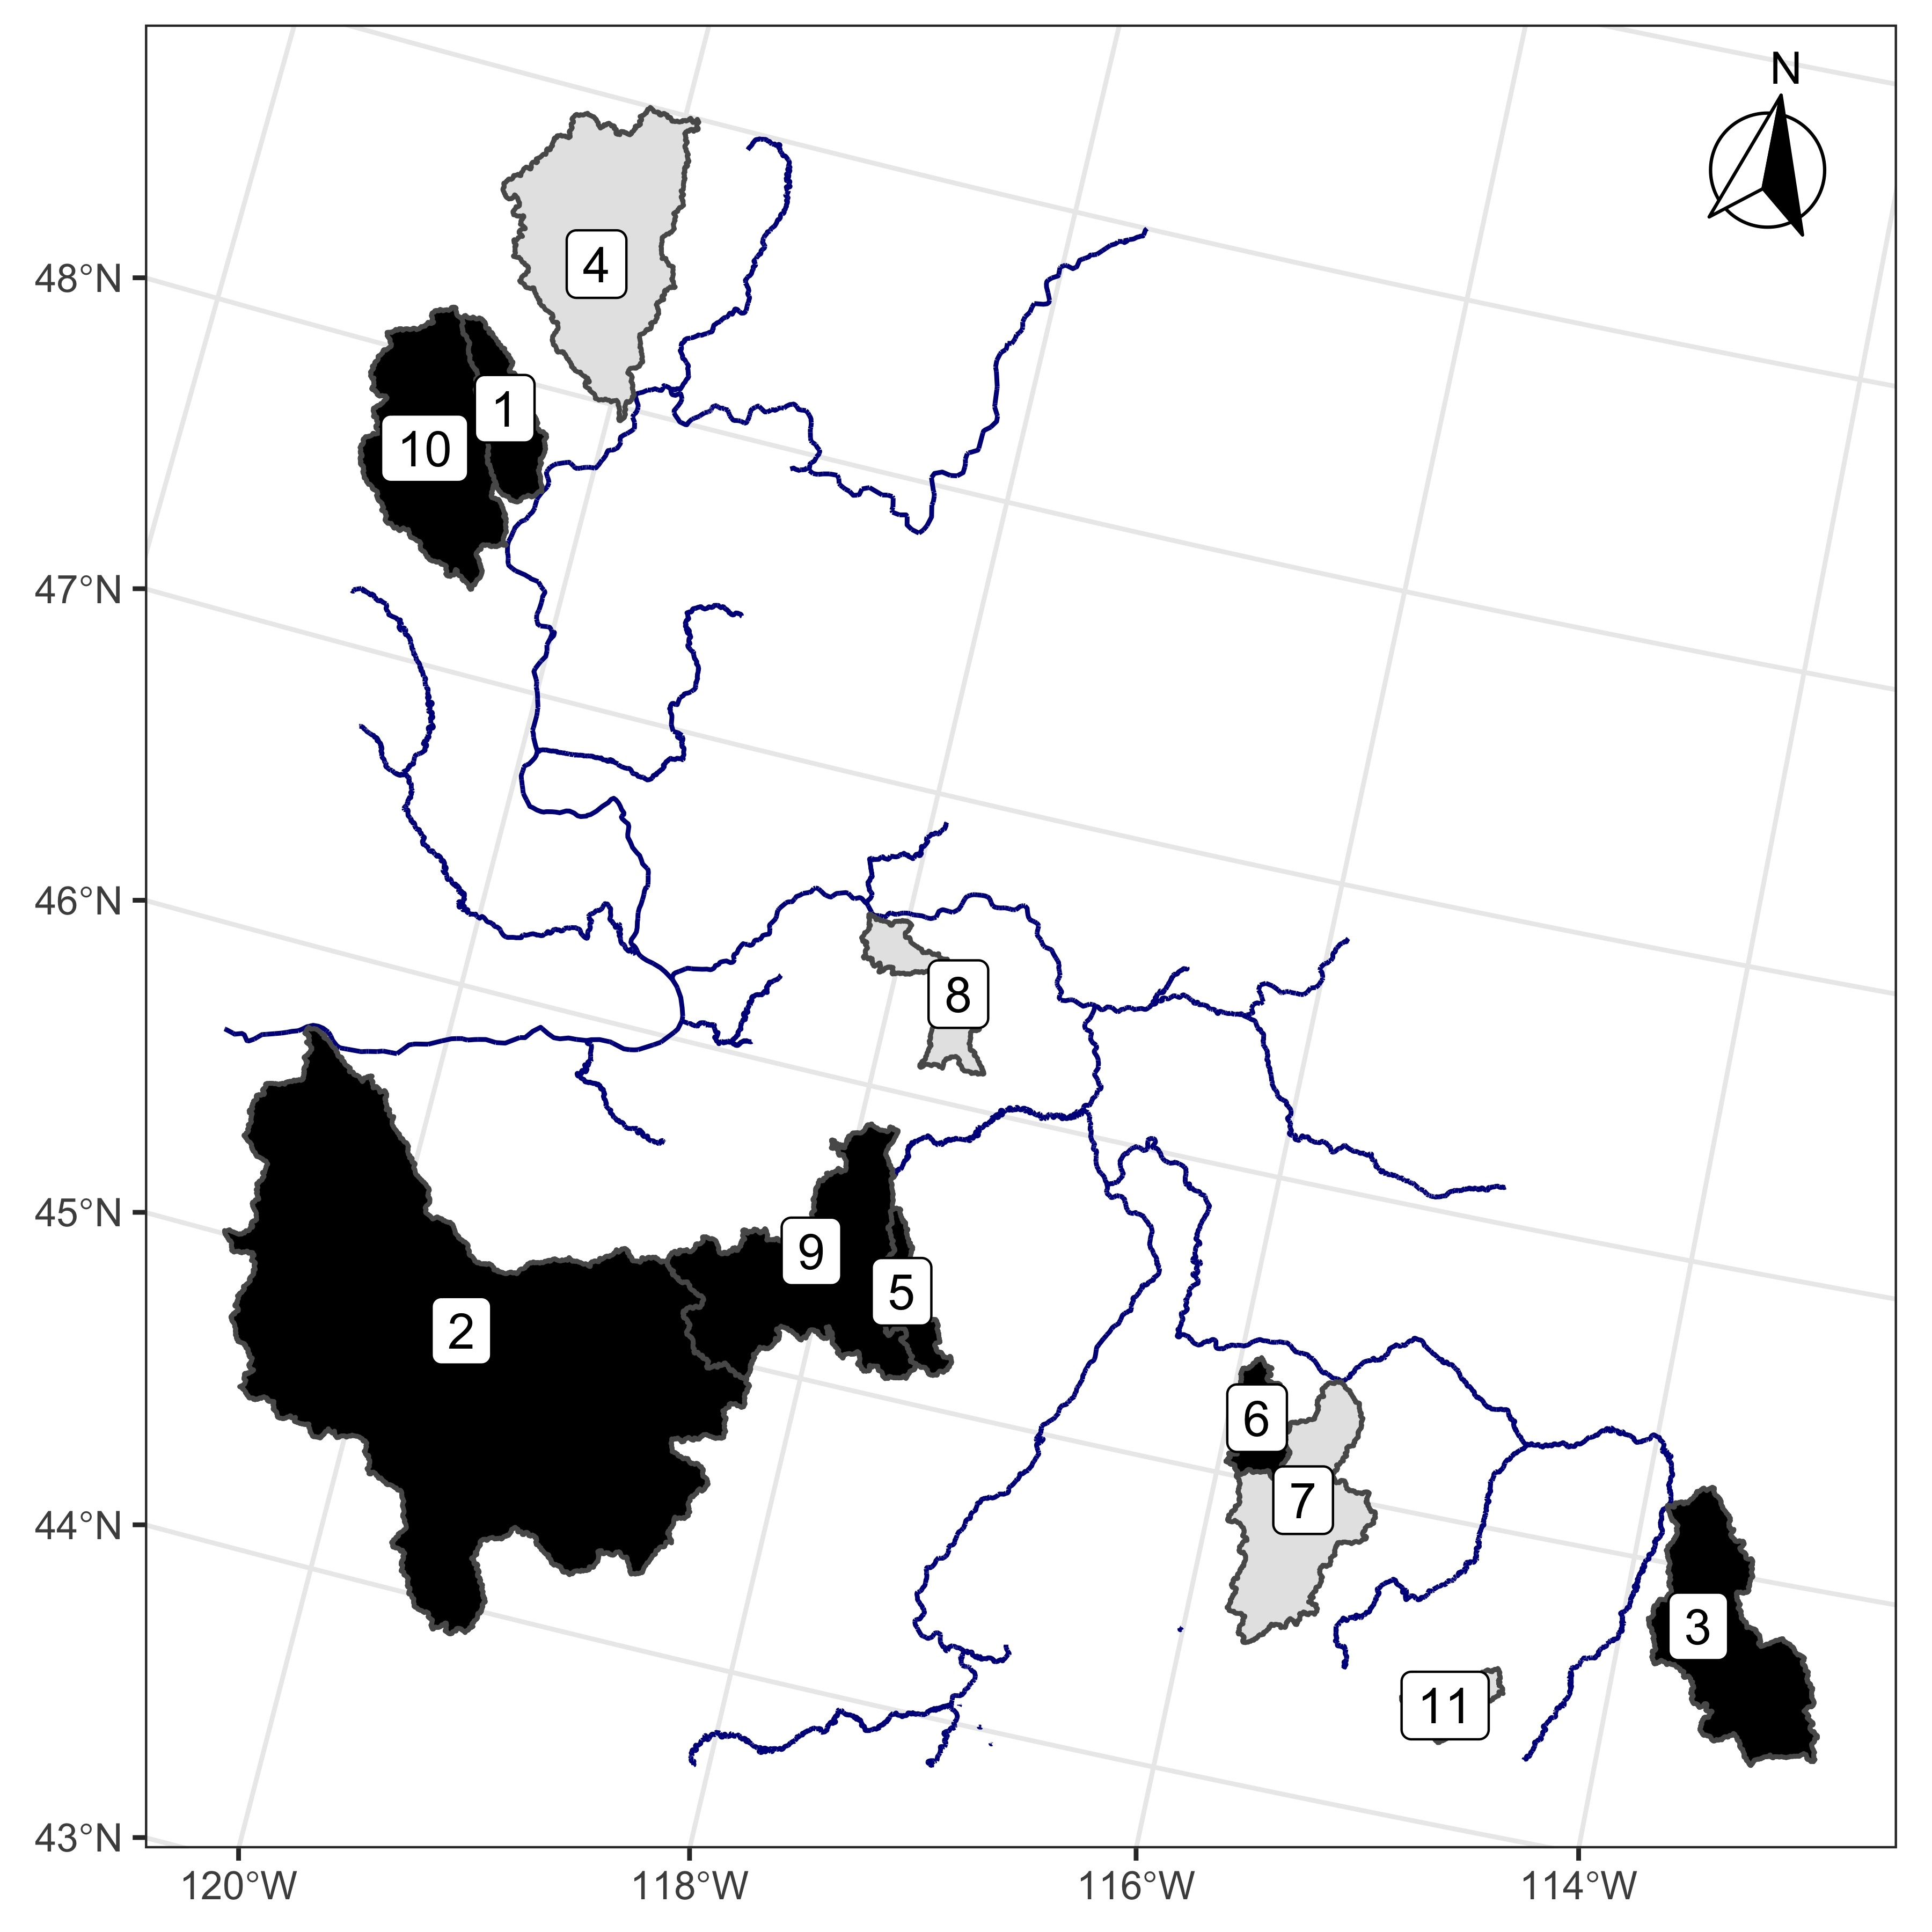

Figure 1: Watersheds with CHaMP habitat data. Watersheds in black also contain paired fish data. Watershed names are: 1 - Entiat, 2 - John Day, 3 - Lemhi, 4 - Methow, 5 - Minam, 6 - Secesh, 7 - South Fork Salmon, 8 - Tucannon, 9 - Upper Grande Ronde, 10 - Wenatchee, 11 - Yankee Fork.

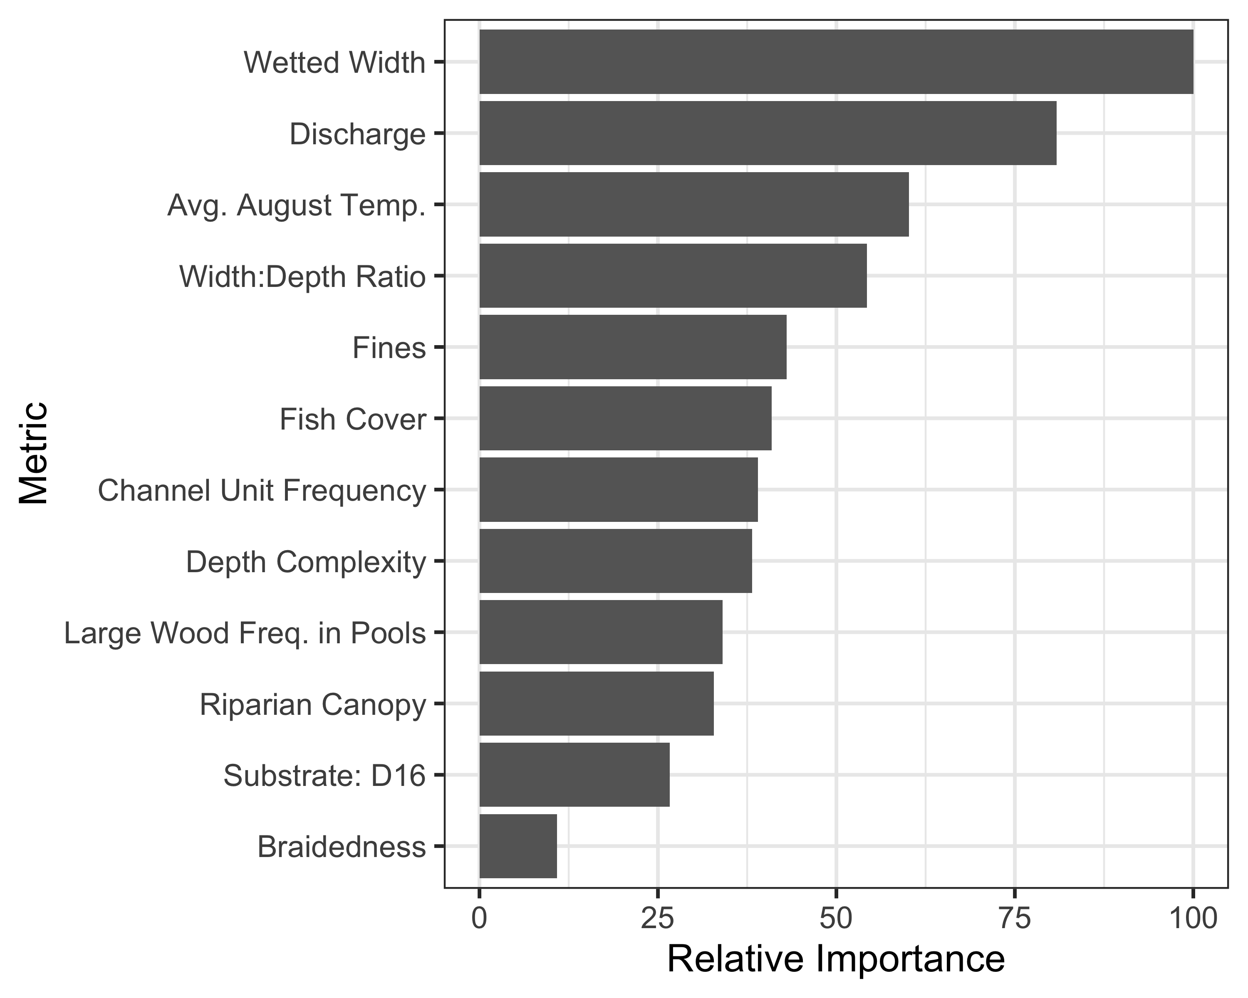

Figure 2: Relative importance of each habitat covariate included in the quantile regression forest (QRF) model to predict habitat capacity, during summer months, for spring/summer Chinook salmon parr

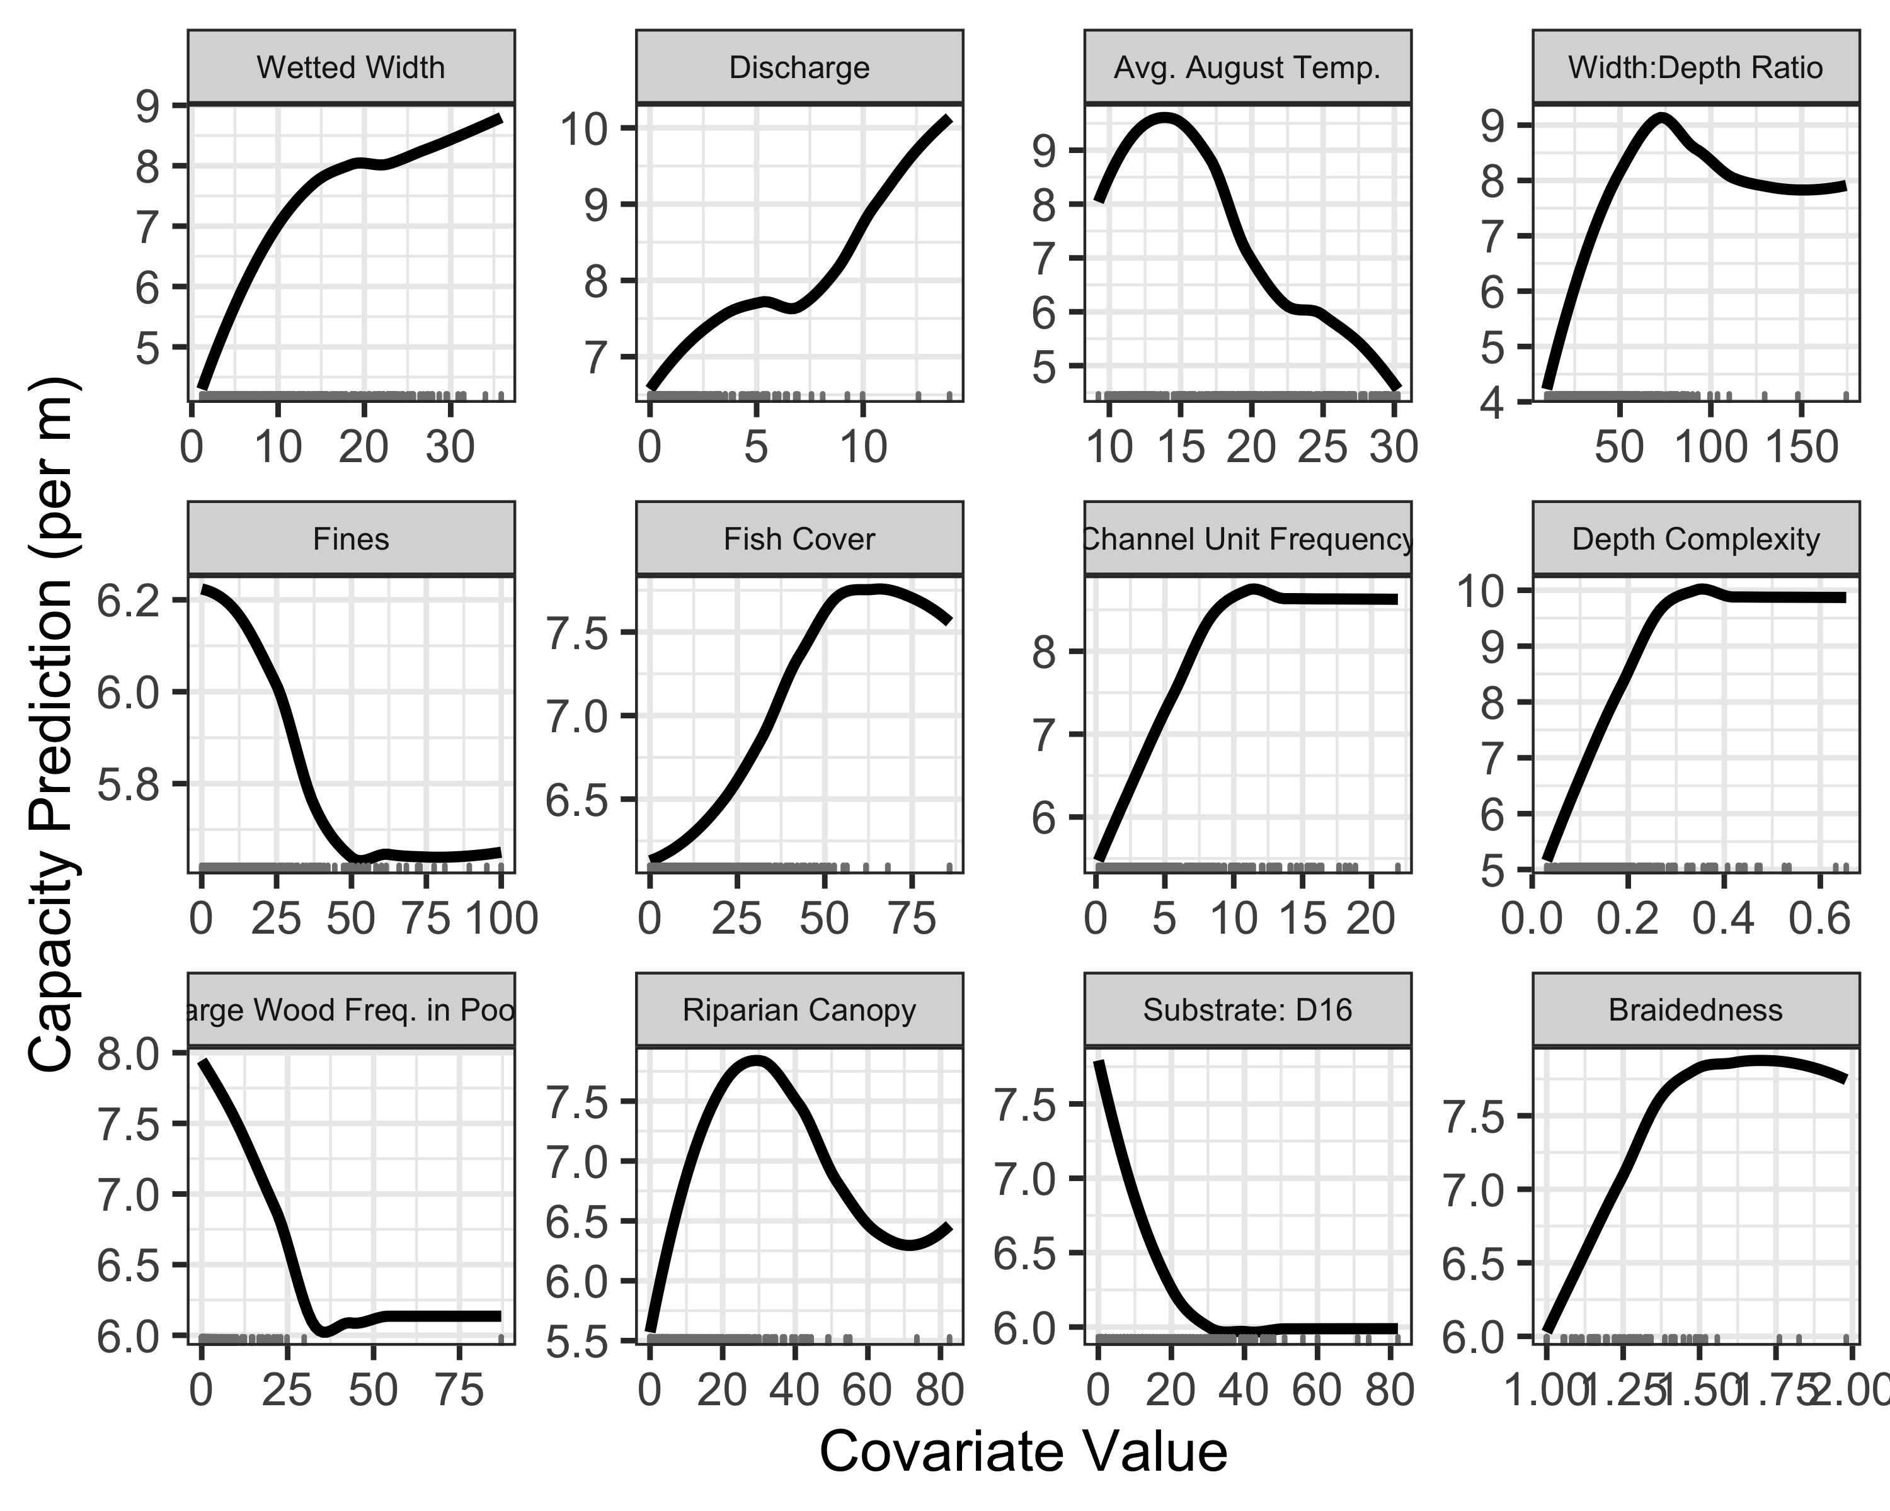

Figure 3: Partial dependence plots for the spring/summer Chinook salmon parr capacity quantile regression forest (QRF) model, depicting how parr capacity shifts as each habitat metric changes, assuming all other habitat metrics remain at their mean values. Tick marks along the X-axis depict observed values.

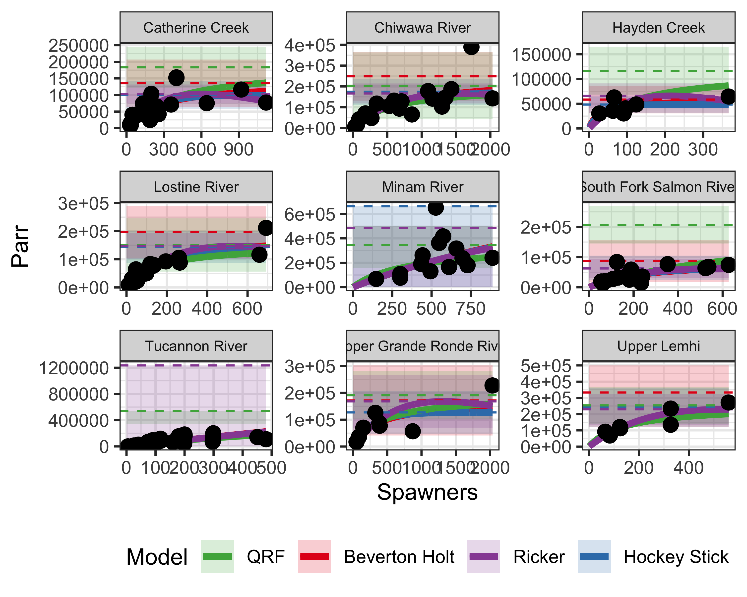

Figure 4: Spawner-recruit data from nine watersheds. Solid lines are the spawner-recruit curve, dashed lines are the estimated capacity, and shaded polygons depict the 95% confidence intervals of capacity. Red corresponds to Beverton-Holt models, purple to Ricker models, blue to hockey stick models, and green to QRF estimates. The QRF solid curve is a Beverton-Holt model with the capacity parameter fixed to the QRF estimate of capacity.

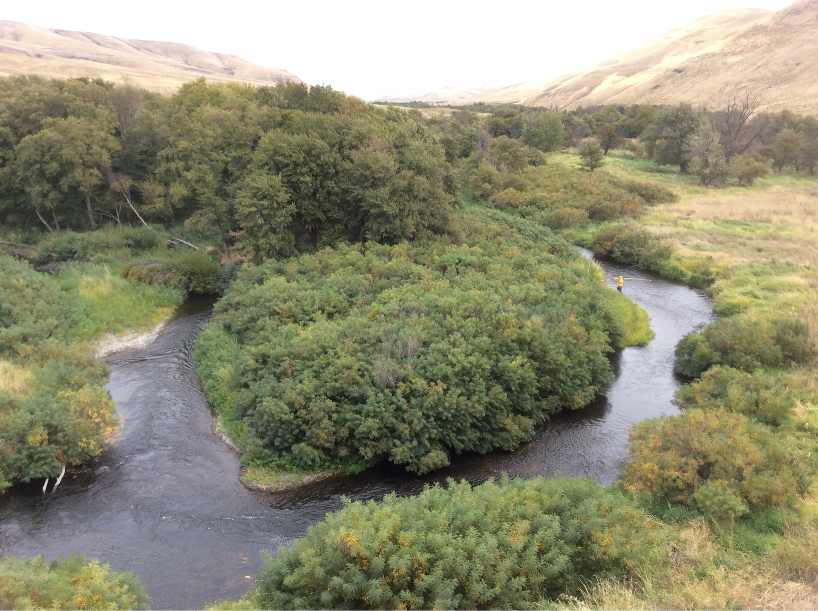

Figure 5: Photo of CHaMP site, CBW05583-415923, with predicted high capacity.

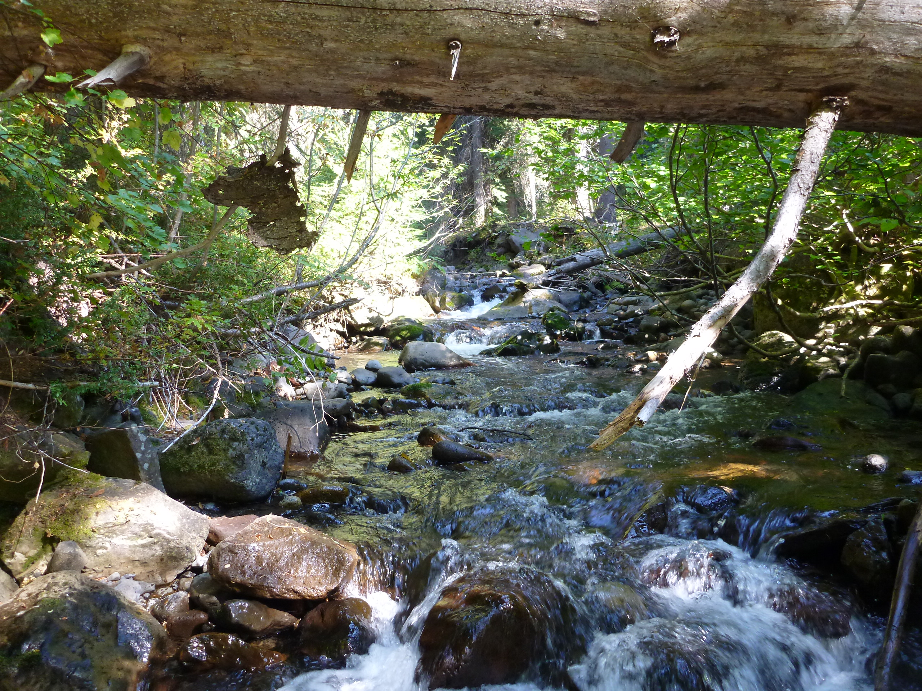

Figure 6: Photo of CHaMP site, CBW05583-109994, with predicted low capacity.

### Colophon

This report was generated on 2020-06-11 14:24:21 using the following computational environment and dependencies:

#> ─ Session info ───────────────────────────────────────────────────────────────  
#> setting value   
#> version R version 3.6.1 (2019-07-05)  
#> os macOS Mojave 10.14.6   
#> system x86_64, darwin15.6.0   
#> ui X11   
#> language (EN)   
#> collate en_US.UTF-8   
#> ctype en_US.UTF-8   
#> tz America/Los_Angeles   
#> date 2020-06-11   
#>   
#> ─ Packages ───────────────────────────────────────────────────────────────────  
#> package * version date lib source   
#> assertthat 0.2.1 2019-03-21 [2] CRAN (R 3.6.0)  
#> backports 1.1.6 2020-04-05 [1] CRAN (R 3.6.2)  
#> bookdown 0.17 2020-01-11 [1] CRAN (R 3.6.0)  
#> broom 0.5.3 2019-12-14 [1] CRAN (R 3.6.0)  
#> callr 3.4.3 2020-03-28 [1] CRAN (R 3.6.2)  
#> cellranger 1.1.0 2016-07-27 [2] CRAN (R 3.6.0)  
#> class 7.3-15 2019-01-01 [2] CRAN (R 3.6.1)  
#> classInt 0.4-2 2019-10-17 [1] CRAN (R 3.6.0)  
#> cli 2.0.2 2020-02-28 [1] CRAN (R 3.6.0)  
#> colorspace 1.4-1 2019-03-18 [2] CRAN (R 3.6.0)  
#> crayon 1.3.4 2017-09-16 [2] CRAN (R 3.6.0)  
#> DBI 1.0.0 2018-05-02 [2] CRAN (R 3.6.0)  
#> dbplyr 1.4.2 2019-06-17 [2] CRAN (R 3.6.0)  
#> desc 1.2.0 2018-05-01 [1] CRAN (R 3.6.0)  
#> devtools 2.2.1 2019-09-24 [1] CRAN (R 3.6.0)  
#> digest 0.6.25 2020-02-23 [1] CRAN (R 3.6.0)  
#> dplyr * 0.8.5 2020-03-07 [1] CRAN (R 3.6.0)  
#> e1071 1.7-3 2019-11-26 [1] CRAN (R 3.6.0)  
#> ellipsis 0.3.0 2019-09-20 [2] CRAN (R 3.6.0)  
#> english * 1.2-5 2020-01-26 [1] CRAN (R 3.6.1)  
#> evaluate 0.14 2019-05-28 [2] CRAN (R 3.6.0)  
#> fansi 0.4.1 2020-01-08 [1] CRAN (R 3.6.0)  
#> farver 2.0.3 2020-01-16 [1] CRAN (R 3.6.0)  
#> forcats * 0.5.0 2020-03-01 [1] CRAN (R 3.6.0)  
#> fs 1.3.1 2019-05-06 [2] CRAN (R 3.6.0)  
#> generics 0.0.2 2018-11-29 [2] CRAN (R 3.6.0)  
#> ggplot2 * 3.3.0 2020-03-05 [1] CRAN (R 3.6.0)  
#> glue 1.4.0 2020-04-03 [1] CRAN (R 3.6.2)  
#> gtable 0.3.0 2019-03-25 [2] CRAN (R 3.6.0)  
#> haven 2.2.0 2019-11-08 [2] CRAN (R 3.6.0)  
#> highr 0.8 2019-03-20 [2] CRAN (R 3.6.0)  
#> hms 0.5.3 2020-01-08 [1] CRAN (R 3.6.0)  
#> htmltools 0.4.0 2019-10-04 [2] CRAN (R 3.6.0)  
#> httr 1.4.1 2019-08-05 [2] CRAN (R 3.6.0)  
#> janitor * 2.0.1 2020-04-12 [1] CRAN (R 3.6.2)  
#> jpeg 0.1-8.1 2019-10-24 [1] CRAN (R 3.6.0)  
#> jsonlite 1.6 2018-12-07 [2] CRAN (R 3.6.0)  
#> KernSmooth 2.23-15 2015-06-29 [2] CRAN (R 3.6.1)  
#> knitr * 1.27 2020-01-16 [1] CRAN (R 3.6.0)  
#> labeling 0.3 2014-08-23 [2] CRAN (R 3.6.0)  
#> lattice 0.20-38 2018-11-04 [2] CRAN (R 3.6.1)  
#> lifecycle 0.2.0 2020-03-06 [1] CRAN (R 3.6.0)  
#> lubridate 1.7.8 2020-04-06 [1] CRAN (R 3.6.2)  
#> magrittr * 1.5 2014-11-22 [1] CRAN (R 3.6.0)  
#> Matrix * 1.2-17 2019-03-22 [2] CRAN (R 3.6.1)  
#> memoise 1.1.0 2017-04-21 [1] CRAN (R 3.6.0)  
#> mgcv 1.8-28 2019-03-21 [2] CRAN (R 3.6.1)  
#> minerva 1.5.8 2019-05-27 [1] CRAN (R 3.6.0)  
#> mitools 2.4 2019-04-26 [1] CRAN (R 3.6.0)  
#> modelr 0.1.5 2019-08-08 [2] CRAN (R 3.6.0)  
#> munsell 0.5.0 2018-06-12 [2] CRAN (R 3.6.0)  
#> nlme 3.1-142 2019-11-07 [1] CRAN (R 3.6.0)  
#> pander * 0.6.3 2018-11-06 [1] CRAN (R 3.6.0)  
#> pillar 1.4.3 2019-12-20 [1] CRAN (R 3.6.0)  
#> pkgbuild 1.0.8 2020-05-07 [1] CRAN (R 3.6.2)  
#> pkgconfig 2.0.3 2019-09-22 [2] CRAN (R 3.6.0)  
#> pkgload 1.0.2 2018-10-29 [1] CRAN (R 3.6.0)  
#> prettyunits 1.1.1 2020-01-24 [1] CRAN (R 3.6.0)  
#> processx 3.4.2 2020-02-09 [1] CRAN (R 3.6.0)  
#> ps 1.3.3 2020-05-08 [1] CRAN (R 3.6.2)  
#> purrr * 0.3.4 2020-04-17 [1] CRAN (R 3.6.2)  
#> QRFpaper * 0.0.0.9000 2020-06-08 [1] local   
#> quantregForest 1.3-7 2017-12-19 [2] CRAN (R 3.6.0)  
#> R6 2.4.1 2019-11-12 [2] CRAN (R 3.6.0)  
#> randomForest 4.6-14 2018-03-25 [2] CRAN (R 3.6.0)  
#> RColorBrewer 1.1-2 2014-12-07 [2] CRAN (R 3.6.0)  
#> Rcpp 1.0.4.6 2020-04-09 [1] CRAN (R 3.6.1)  
#> readr * 1.3.1 2018-12-21 [2] CRAN (R 3.6.0)  
#> readxl 1.3.1 2019-03-13 [1] CRAN (R 3.6.0)  
#> remotes 2.1.0 2019-06-24 [1] CRAN (R 3.6.0)  
#> reprex 0.3.0 2019-05-16 [2] CRAN (R 3.6.0)  
#> rlang 0.4.6 2020-05-02 [1] CRAN (R 3.6.2)  
#> rmarkdown 2.1 2020-01-20 [1] CRAN (R 3.6.1)  
#> rprojroot 1.3-2 2018-01-03 [1] CRAN (R 3.6.0)  
#> rstudioapi 0.11 2020-02-07 [1] CRAN (R 3.6.0)  
#> rvest 0.3.5 2019-11-08 [2] CRAN (R 3.6.0)  
#> scales 1.1.0 2019-11-18 [2] CRAN (R 3.6.0)  
#> sessioninfo 1.1.1 2018-11-05 [1] CRAN (R 3.6.0)  
#> sf * 0.9-3 2020-05-04 [1] CRAN (R 3.6.2)  
#> snakecase 0.11.0 2019-05-25 [1] CRAN (R 3.6.0)  
#> stringi 1.4.6 2020-02-17 [1] CRAN (R 3.6.0)  
#> stringr * 1.4.0 2019-02-10 [2] CRAN (R 3.6.0)  
#> survey * 3.36 2019-04-27 [1] CRAN (R 3.6.0)  
#> survival * 2.44-1.1 2019-04-01 [2] CRAN (R 3.6.1)  
#> testthat 2.3.2 2020-03-02 [1] CRAN (R 3.6.0)  
#> tibble * 3.0.1 2020-04-20 [1] CRAN (R 3.6.2)  
#> tidyr * 1.0.3 2020-05-07 [1] CRAN (R 3.6.2)  
#> tidyselect 1.0.0 2020-01-27 [1] CRAN (R 3.6.0)  
#> tidyverse * 1.3.0 2019-11-21 [1] CRAN (R 3.6.0)  
#> units 0.6-5 2019-10-08 [1] CRAN (R 3.6.0)  
#> usethis 1.5.1 2019-07-04 [1] CRAN (R 3.6.0)  
#> vctrs 0.2.4 2020-03-10 [1] CRAN (R 3.6.0)  
#> withr 2.2.0 2020-04-20 [1] CRAN (R 3.6.2)  
#> xfun 0.12 2020-01-13 [1] CRAN (R 3.6.0)  
#> xml2 1.2.2 2019-08-09 [2] CRAN (R 3.6.0)  
#> yaml 2.2.0 2018-07-25 [2] CRAN (R 3.6.0)  
#>   
#> [1] /Users/seek/Library/R/3.6/library  
#> [2] /Library/Frameworks/R.framework/Versions/3.6/Resources/library

The current Git commit details are:

#> Local: master /Users/seek/Documents/GitProjects/MyProjects/QRFpaper  
#> Remote: master @ origin (git@github.com:KevinSee/QRFpaper.git)  
#> Head: [347a3c0] 2020-06-11: Merge branch 'master' of github.com:KevinSee/QRFpaper